**FAST DORMANCY in Layer3**

*Fast dormancy was initially thought of by UE vendors as a way of saving battery life.* Rather than staying in the power hungry state CELL_DCH for as long as the network timers dictated, the UE could send a SCRI RRC message (Signalling Connection Release Indication) which would result in an immediate transition to IDLE.

The 3GPP finally addresses the whole issue in Rel8, with the standardized implementation of Fast Dormancy. Now the network indicates it supports Fast Dormancy by broadcasting timer T323 in SIB1.

If timer T323 is broadcast in System Information Block type1, it means that the network supports this Rel-8 mechanism. This timer can take values : (0,5,10,20,30,60,90,120) seconds. The use of 0 secs indicates no need to apply the inhibit timer. Inhibit timer is started after a FD(Fast Dormancy) Request is sent, and until the timer is elapsed, UE can't send any further FD Request. If T323 = 120, the UE can't send any FD request before 2 minutes after a transmission ends or the transmission of a previous FD request.

**General signal flow for Fast Dormancy (Release 8)**

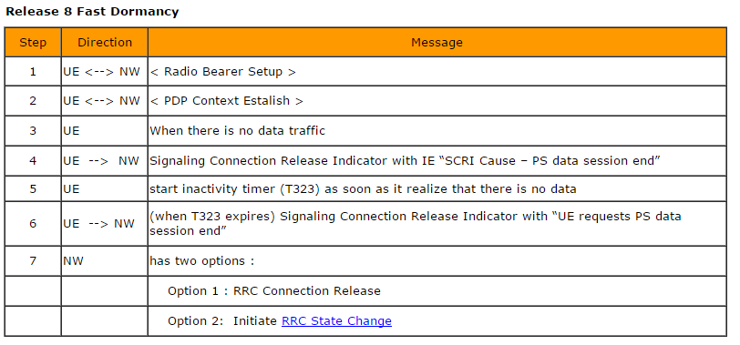

**Example SwissQual (RRC Messages – SIB1)**

